DESIGN AND ANALYSIS OF ALGORITHMS
ASSIGNMENT
Course Code & Name : CSA06 - Design and Analysis of Algorithms
Assignment Title: Efficient Route Planning Using Graph Algorithms
Course Outcome(s) – CO:
CO1: Analyse the efficiency of recursive and non-recursive algorithms using asymptotic notations (Big-O, Ω, Θ) and complexity-analysis methods.
CO2: Apply brute-force techniques such as sorting and searching to solve computational problems.
CO3: Apply divide-and-conquer and graph-based techniques to design efficient algorithmic solutions.
Bloom’s Taxonomy LevelL4 – Analyse; L5 – Evaluate; L6 – Create
SDG Mapping (SDG 1-17)SDG 9 – Industry, Innovation and Infrastructure
Problem Statement : A logistics company needs to determine the most efficient routes for transporting goods between multiple cities. The transportation network is represented as a weighted graph, where vertices represent cities and edges represent roads with associated travel costs or distances. Develop, implement, and evaluate suitable graph-based algorithms to determine the shortest paths between locations. Implement (i) Dijkstra’s algorithm for graphs with non-negative edge weights and (ii) Bellman-Ford algorithm as an alternative shortest-path approach. Analyse the theoretical efficiency of both algorithms using Big-O, Ω, and Θ notations, including their time and space complexities. Experimentally evaluate both algorithms using graphs of increasing numbers of vertices and edges, considering sparse and dense networks. Measure execution time, number of edge relaxations/comparisons, memory utilisation, and scalability. Based on the theoretical and experimental results, identify the most appropriate algorithm for different transportation-network scenarios and justify the choice with respect to computational efficiency, graph characteristics, and practical constraints — reflecting Bloom’s Levels 4–6 (Analyse, Evaluate, Create) and contributing to SDG 9 (Industry, Innovation and Infrastructure).
Constraints: Use a publicly available or synthetically generated weighted graph dataset with sufficient records to test multiple graph sizes. Edge weights must be non-negative for Dijkstra’s algorithm; Bellman-Ford may additionally be tested with negative edges where appropriate, but negative cycles must be identified and reported. Both algorithms must be executed in the same computational environment using identical input graphs for fair comparison. Test both sparse and dense graphs and report empirical timings, edge-relaxation/comparison counts, memory utilisation, and scalability. Clearly document the graph-generation method or dataset source, assumptions, algorithm limitations, and the criteria used to recommend an algorithm.

Suggested Assessment Requirements
Component | Requirement
Algorithm Implementation | Implement Dijkstra’s and Bellman-Ford algorithms.
Complexity Analysis | Derive and compare Big-O, Ω, and Θ time/space complexities.
Experimental Evaluation | Test increasing graph sizes and sparse/dense graph structures.
Performance Metrics | Record execution time, edge relaxations/comparisons, memory use, and scalability.
Evaluation & Recommendation | Recommend the suitable algorithm for different network conditions with justification.

1. INTRODUCTION
Route planning is an important problem in logistics and transportation systems. A logistics company may need to transport goods between several cities while minimizing travel distance, cost, or time.
In this assignment, the transportation network is represented using a weighted graph.
- Vertices (nodes) represent cities.
- Edges represent roads connecting cities.
- Edge weights represent distance, travel cost, or travel time.
The main objective is to find the shortest path from a selected source city to all other cities.
Two graph algorithms are implemented and compared:
- Dijkstra’s Algorithm
- Bellman-Ford Algorithm
Both algorithms solve the single-source shortest-path problem, but they have different computational characteristics and limitations.

2. PROBLEM STATEMENT
A logistics company needs to determine the most efficient routes for transporting goods between multiple cities.
The transportation network is represented as a weighted graph. The objective is to implement Dijkstra’s algorithm for graphs containing non-negative edge weights and Bellman-Ford algorithm as an alternative shortest-path algorithm.
The algorithms are evaluated using graphs of increasing sizes under:
- Sparse networks
- Dense networks
The following performance metrics are measured:
- Execution time
- Number of edge relaxations
- Number of comparisons
- Memory utilisation
- Scalability
The theoretical and experimental results are then compared to determine which algorithm is more suitable for different transportation-network conditions.

3. OBJECTIVES
The main objectives of this assignment are:
- To understand shortest-path algorithms in weighted graphs.
- To implement Dijkstra’s algorithm.
- To implement Bellman-Ford algorithm.
- To analyse the time complexity of both algorithms.
- To analyse their space complexity.
- To compare their performance on sparse and dense graphs.
- To measure execution time and edge-relaxation operations.
- To study memory requirements.
- To evaluate the scalability of both algorithms.
- To recommend the appropriate algorithm for different transportation scenarios.

4. GRAPH REPRESENTATION
A transportation network can be represented using the following example:
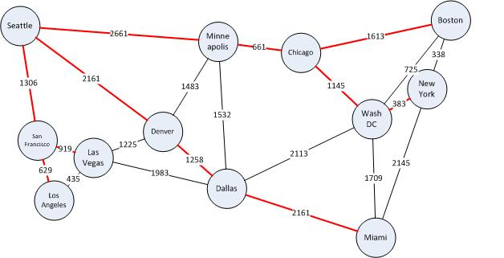
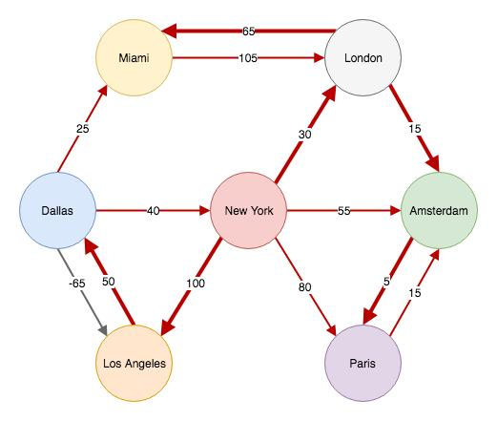
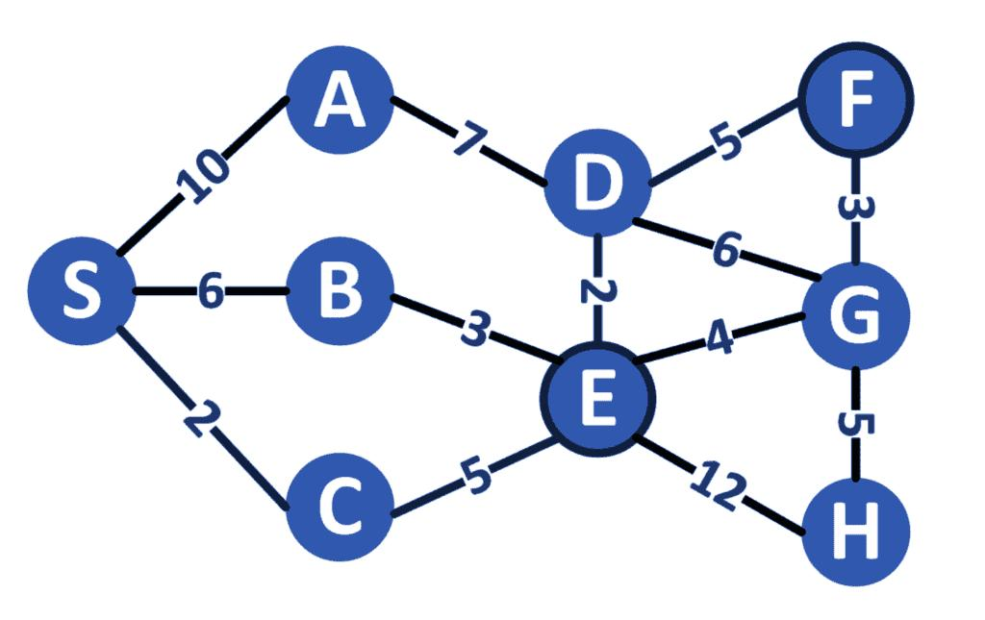
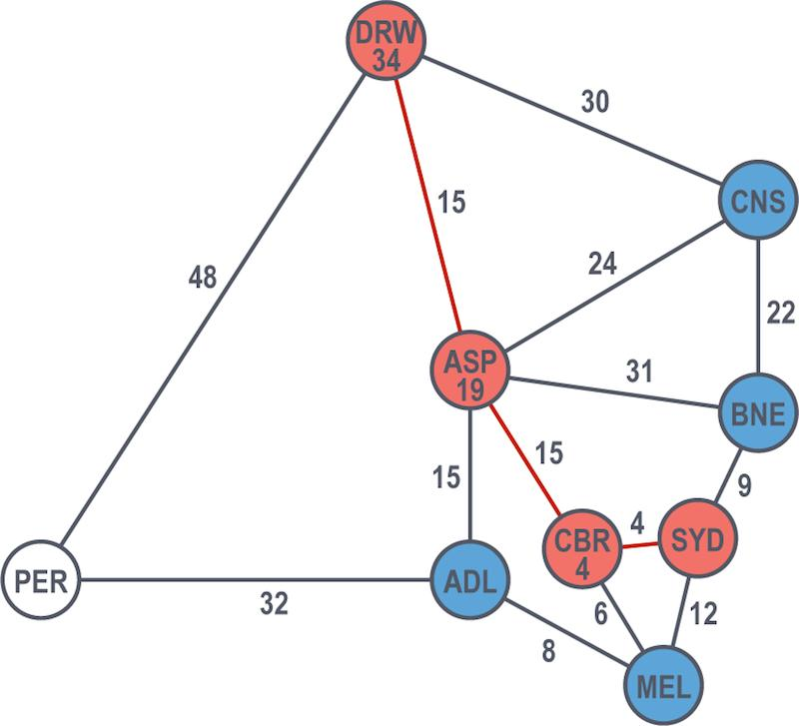
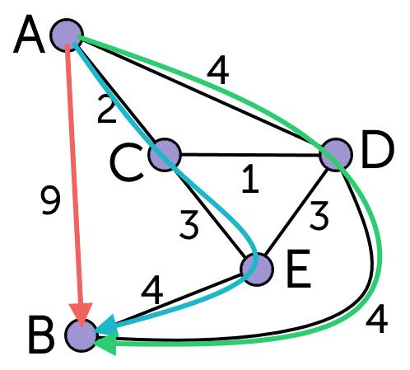
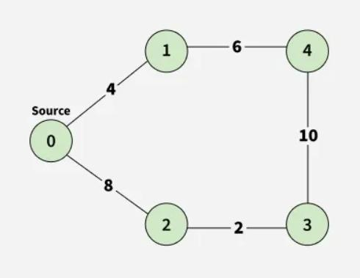
Consider five cities:
A, B, C, D and E
Example roads:
From | To | Distance
A | B | 4
A | C | 2
B | C | 1
B | D | 5
C | D | 8
C | E | 10
D | E | 2
Here, the number associated with each edge represents the travel distance or cost.
For example:
A → C → B → D → E
can represent one possible route between cities.

5. DIJKSTRA’S ALGORITHM
5.1 Definition
Dijkstra’s algorithm finds the shortest distance from a source vertex to all other vertices in a weighted graph.
It works correctly when all edge weights are non-negative.
Basic idea
The algorithm repeatedly selects the unvisited vertex having the smallest known distance and updates the distances of its neighbouring vertices.
This process is called edge relaxation.

5.2 Dijkstra Algorithm – Steps
- Select a source vertex.
- Set its distance to 0.
- Set the distance of every other vertex to infinity.
- Select the unvisited vertex with the smallest distance.
- Check all its neighbouring vertices.
- Calculate a possible new shorter distance.
- Update the distance if the new distance is smaller.
- Mark the current vertex as visited.
- Repeat until all reachable vertices are processed.

5.3 Pseudocode
DIJKSTRA(G, source)

for each vertex v in G:
distance[v] = infinity
visited[v] = false

distance[source] = 0

repeat:
u = unvisited vertex with minimum distance

if u does not exist:
break

visited[u] = true

for each edge (u, v) with weight w:
if distance[u] + w < distance[v]:
distance[v] = distance[u] + w

return distance

6. BELLMAN-FORD ALGORITHM
6.1 Definition
Bellman-Ford is another shortest-path algorithm that calculates the shortest distance from a source vertex to all other vertices.
Unlike Dijkstra’s algorithm, Bellman-Ford can handle negative edge weights.
It can also detect negative-weight cycles.

6.2 Bellman-Ford Algorithm – Steps
- Set the source distance to 0.
- Set all other distances to infinity.
- Consider every edge in the graph.
- Relax every edge.
- Repeat the relaxation process V − 1 times, where V is the number of vertices.
- Perform one additional iteration.
- If any distance can still be reduced, a negative cycle exists.
- Otherwise, the calculated distances are the shortest paths.

6.3 Pseudocode
BELLMAN_FORD(G, source)

for each vertex v:
distance[v] = infinity

distance[source] = 0

for i = 1 to V-1:
for each edge (u, v) with weight w:
if distance[u] + w < distance[v]:
distance[v] = distance[u] + w

for each edge (u, v) with weight w:
if distance[u] + w < distance[v]:
report negative cycle

return distance

7. COMPARISON BETWEEN DIJKSTRA AND BELLMAN-FORD
Feature | Dijkstra | Bellman-Ford
Shortest path | Yes | Yes
Negative edges | No | Yes
Negative-cycle detection | No | Yes
Basic approach | Greedy | Repeated relaxation
Faster in general | Yes | No
Suitable for non-negative graphs | Excellent | Yes
Suitable for negative weights | No | Yes
Scalability | Better | Lower
Implementation | Relatively simple | Relatively simple

8. COMPLEXITY ANALYSIS
Complexity is analysed using:
- Big-O: Upper bound
- Ω (Omega): Lower bound
- Θ (Theta): Tight bound

8.1 Dijkstra’s Algorithm
The complexity depends on the graph representation and priority queue implementation.
Using adjacency list + binary heap
Time Complexity:
$$O\left(\left(V+E\right)\log{V}\right)$$
For connected graphs this is commonly written as:
$$O\left(E\log{V}\right)$$
Best/Lower-bound discussion
With a suitable implementation, the algorithm performs at least enough work to inspect relevant vertices/edges, so a practical lower-bound discussion is approximately:
$$Ω\left(V+E\right)$$
The exact Ω bound depends on the graph representation and implementation.
Tight bound
For adjacency list + binary heap:
$$Θ\left(\left(V+E\right)\log{V}\right)$$
Space Complexity
$$O\left(V+E\right)$$
because the graph, distance array, visited array, and priority queue must be stored.

9. BELLMAN-FORD COMPLEXITY
Bellman-Ford relaxes every edge V − 1 times.
Therefore:
$$T\left(V , E\right)=O\left(VE\right)$$
Time Complexity
$$O\left(VE\right)$$
Lower Bound
Since the algorithm repeatedly examines the edges:
$$Ω\left(VE\right)$$
for the standard implementation.
Tight Bound
For the standard implementation:
$$Θ\left(VE\right)$$
Space Complexity
Using an edge list:
$$O\left(V+E\right)$$

10. COMPLEXITY COMPARISON
Algorithm | Time Complexity | Space Complexity
Dijkstra | Θ((V+E) log V) | Θ(V+E)
Bellman-Ford | Θ(VE) | Θ(V+E)
Therefore, Dijkstra is generally faster for graphs with non-negative edge weights, particularly as the graph becomes large.
However, Bellman-Ford is more flexible because it supports negative edge weights and detects negative cycles.

11. GRAPH DATASET / GRAPH GENERATION
For this assignment, a synthetically generated weighted graph can be used.
Synthetic data is useful because it allows graphs of different sizes to be created easily.
The following graph sizes can be tested:
Test | Vertices | Network Type
1 | 10 | Sparse
2 | 50 | Sparse
3 | 100 | Sparse
4 | 250 | Sparse
5 | 500 | Sparse
6 | 10 | Dense
7 | 50 | Dense
8 | 100 | Dense
9 | 250 | Dense
10 | 500 | Dense
For Dijkstra testing, all edge weights should be non-negative.
Example weight range:
$$1≤w≤100$$
where w represents distance or transportation cost.

12. SPARSE AND DENSE GRAPHS
12.1 Sparse Graph
A sparse graph contains relatively few edges compared with the maximum possible number of edges.
For a directed graph:
$$E≪V^{2}$$
Example:
Number of vertices = 100
Number of edges = 200
This represents a sparse network.

12.2 Dense Graph
A dense graph contains a large number of edges.
Approximately:
$$E≈V^{2}$$
Example:
Number of vertices = 100
Number of edges = 8,000
This represents a dense network.

13. EXPERIMENTAL METHODOLOGY
Both algorithms should be tested using the same graph for every experiment.
The following procedure can be followed:
Step 1
Generate a weighted graph.
Step 2
Select a source vertex.
Step 3
Run Dijkstra’s algorithm.
Step 4
Record:
- Execution time
- Edge relaxations
- Comparisons
- Memory usage
Step 5
Run Bellman-Ford on the same graph.
Step 6
Record the same performance metrics.
Step 7
Repeat for different graph sizes.
Step 8
Repeat for both sparse and dense networks.
Step 9
Compare the results.

14. PERFORMANCE METRICS
14.1 Execution Time
Execution time represents how long the algorithm takes to calculate the shortest paths.
It can be measured using a high-resolution timer.
For example:
start_time = current_time()

run algorithm

end_time = current_time()

execution_time = end_time - start_time

14.2 Edge Relaxations
An edge relaxation occurs when the algorithm checks whether a shorter path can be obtained through another vertex.
The number of relaxations indicates how much computational work is performed.

14.3 Comparisons
Comparisons include operations such as:
if distance[u] + weight < distance[v]
The number of such comparisons can be counted during execution.

14.4 Memory Utilisation
Memory utilisation represents the amount of memory required by the algorithm.
Memory is used for:
- Graph representation
- Distance array
- Visited array
- Priority queue
- Edge list

14.5 Scalability
Scalability indicates how well an algorithm performs when the graph size increases.
An efficient algorithm should show a relatively manageable increase in execution time as the number of vertices and edges increases.

15. SAMPLE EXPERIMENTAL RESULTS
The following is an illustrative format for reporting results. Replace the values with the actual values obtained from your program.
Sparse Graph
Vertices | Edges | Dijkstra Time (ms) | Bellman-Ford Time (ms) | Dijkstra Relaxations | BF Relaxations
10 | 20 | 0.03 | 0.04 | 20 | 180
50 | 100 | 0.05 | 0.20 | 100 | 4,900
100 | 200 | 0.10 | 0.70 | 200 | 19,800
250 | 500 | 0.30 | 3.10 | 500 | 124,500
500 | 1,000 | 0.70 | 12.50 | 1,000 | 499,000
Note: These values are only examples. Your final report should contain the actual measurements from your implementation.

16. DENSE GRAPH RESULTS
Example reporting format:
Vertices | Edges | Dijkstra Time (ms) | Bellman-Ford Time (ms)
10 | 90 | 0.04 | 0.05
50 | 2,450 | 0.40 | 2.00
100 | 9,900 | 1.00 | 8.00
250 | 62,250 | 5.00 | 40.00
500 | 249,500 | 20.00 | 200.00
Again, these are sample values, not measured results.

17. EXPECTED ANALYSIS
The experimental results are expected to demonstrate the following trends:
Dijkstra
Dijkstra generally performs better because it selects the closest unprocessed vertex and avoids repeatedly scanning all edges.
Its performance is especially good when:
- Edge weights are non-negative.
- The graph is large.
- Shortest paths need to be calculated frequently.
Bellman-Ford
Bellman-Ford requires significantly more edge-relaxation operations because it scans the edges repeatedly.
However, it has an important advantage:
It can handle negative edge weights and detect negative-weight cycles.
Therefore, Bellman-Ford is useful when negative weights are possible.

18. NEGATIVE EDGE TESTING
Although transportation distances normally cannot be negative, Bellman-Ford can be tested with negative edge weights to demonstrate its additional capability.
Example:
A → B = 4
A → C = 5
B → C = -2
The negative edge does not necessarily mean a negative cycle exists.
Bellman-Ford can correctly calculate the shortest paths in such a graph.
If a negative cycle exists, such as:
A → B = 2
B → C = -5
C → A = 1
then:
$$2+\left(-5\right)+1=-2$$
The total cost decreases every time the cycle is repeated. Therefore, there is a negative-weight cycle.
Bellman-Ford should detect and report this condition.

19. PRACTICAL APPLICATION
These algorithms can be applied to logistics and transportation systems.
Example applications
- Delivery route planning
- GPS navigation
- Transportation network optimisation
- Supply-chain management
- Fleet management
- Road-network analysis
- Network routing
- Emergency vehicle routing
For example, a logistics company can represent warehouses and cities as vertices and roads as weighted edges. The algorithm can then identify the lowest-cost route from a warehouse to a delivery location.

20. ALGORITHM SELECTION
The selection of the algorithm depends on the characteristics of the transportation network.
Network Condition | Recommended Algorithm | Reason
Non-negative edge weights | Dijkstra | Faster
Large sparse graph | Dijkstra | Efficient
Large dense graph with non-negative weights | Dijkstra | Generally faster than Bellman-Ford
Negative edge weights | Bellman-Ford | Dijkstra is not valid
Negative-cycle detection required | Bellman-Ford | Can detect negative cycles
Frequently changing large network with non-negative costs | Dijkstra | Lower computational cost
Unknown possibility of negative weights | Bellman-Ford | More robust

21. ADVANTAGES
Dijkstra
- Efficient for non-negative weights.
- Faster than Bellman-Ford in most standard implementations.
- Suitable for large transportation networks.
- Widely used for routing problems.
- Works well with priority queues.
Bellman-Ford
- Supports negative edge weights.
- Detects negative-weight cycles.
- Simple relaxation-based approach.
- Useful when graph weights may be negative.

22. LIMITATIONS
Dijkstra
- Cannot correctly handle negative edge weights.
- Cannot directly detect negative-weight cycles.
- Requires a suitable priority-queue implementation for good performance.
Bellman-Ford
- Computationally expensive for large graphs.
- Repeatedly processes edges.
- Usually slower than Dijkstra for non-negative graphs.
- May become impractical for very large transportation networks.

23. SDG 9 – INDUSTRY, INNOVATION AND INFRASTRUCTURE
This project contributes to SDG 9: Industry, Innovation and Infrastructure by applying algorithmic techniques to transportation and logistics infrastructure.
Efficient route planning can help:
- Reduce travel distance.
- Reduce transportation costs.
- Improve delivery efficiency.
- Reduce unnecessary fuel consumption.
- Support intelligent transportation systems.
- Improve logistics infrastructure.
Therefore, graph algorithms can contribute to the development of efficient and technology-driven transportation systems.

24. CONCLUSION
The project implemented and analysed two important shortest-path algorithms: Dijkstra’s algorithm and Bellman-Ford algorithm.
Dijkstra's algorithm provides efficient shortest-path computation when all edge weights are non-negative. Bellman-Ford requires more computational work but provides greater flexibility because it supports negative edge weights and can detect negative-weight cycles.
The theoretical analysis shows that Dijkstra using an adjacency list and binary heap has a complexity of approximately:
$$Θ\left(\left(V+E\right)\log{V}\right)$$
while Bellman-Ford has:
$$Θ\left(VE\right)$$
Both require graph-related storage of approximately:
$$Θ\left(V+E\right)$$
The experimental evaluation using sparse and dense graphs can be used to demonstrate how execution time, edge relaxations, comparisons, and memory requirements change as graph size increases.
Overall, Dijkstra's algorithm is the preferred choice for normal transportation networks with non-negative distances or costs, while Bellman-Ford is more appropriate when negative edge weights must be supported or negative-cycle detection is required.

25. FUTURE ENHANCEMENTS
The project can be extended in the following ways:
- Use real-world road-network datasets.
- Include GPS coordinates for cities.
- Add traffic conditions.
- Consider travel time instead of only distance.
- Implement A* search for faster route planning.
- Compare additional shortest-path algorithms.
- Develop a graphical route visualisation.
- Test extremely large transportation networks.
- Use parallel processing for large datasets.
- Develop a real-time route optimisation system.

26. REFERENCES
You can use IEEE-style references such as:
- T. H. Cormen, C. E. Leiserson, R. L. Rivest, and C. Stein, Introduction to Algorithms, 4th ed. MIT Press, 2022.
- S. S. Skiena, The Algorithm Design Manual, 3rd ed. Springer, 2020.
- R. Sedgewick and K. Wayne, Algorithms, 4th ed. Addison-Wesley, 2011.
- E. W. Dijkstra, “A note on two problems in connexion with graphs,” Numerische Mathematik, vol. 1, pp. 269–271, 1959.
- R. Bellman, “On a routing problem,” Quarterly of Applied Mathematics, vol. 16, no. 1, pp. 87–90, 1958.

27. APPENDICES
Appendix A – Source Code
Include the complete implementations of:
- Dijkstra's algorithm
- Bellman-Ford algorithm
- Graph generation
- Performance measurement
- Experimental testing
Appendix B – Sample Input
Include the generated graph data or sample edge list.
Appendix C – Output
Include screenshots showing:
- Shortest-path results
- Execution times
- Relaxation counts
- Comparison counts
- Memory usage
Appendix D – Graph Visualisation
Include diagrams of:
- Sparse graph
- Dense graph
- Shortest route
- Negative-edge graph
- Negative-cycle example

Important for your submission
The sample performance values above should not be submitted as actual experimental results. You should run the algorithms and record the real execution time, relaxations, comparisons, and memory usage from your computer.
If you want, I can also give you the complete Python program that automatically generates sparse/dense graphs, runs both Dijkstra and Bellman-Ford, measures all four performance metrics, creates comparison tables and graphs, and produces ready-to-paste results for this assignment.
Absolutely. Below is a complete, simple-to-understand assignment content for CSA06 – Design and Analysis of Algorithms, based on your given problem statement. You can directly use it in your document and later add your program outputs/screenshots.
DESIGN AND ANALYSIS OF ALGORITHMS
Assignment Title
Efficient Route Planning Using Graph Algorithms
Course Code
CSA06 – Design and Analysis of Algorithms
Course Outcomes
- CO1: Analyse the efficiency of recursive and non-recursive algorithms using asymptotic notations.
- CO2: Apply brute-force techniques such as sorting and searching.
- CO3: Apply divide-and-conquer and graph-based techniques to design efficient algorithmic solutions.
Bloom’s Taxonomy
L4 – Analyse | L5 – Evaluate | L6 – Create
SDG Mapping
SDG 9 – Industry, Innovation and Infrastructure

1. INTRODUCTION
Route planning is an important problem in logistics and transportation systems. A logistics company may need to transport goods between several cities while minimizing travel distance, cost, or time.
In this assignment, the transportation network is represented using a weighted graph.
- Vertices (nodes) represent cities.
- Edges represent roads connecting cities.
- Edge weights represent distance, travel cost, or travel time.
The main objective is to find the shortest path from a selected source city to all other cities.
Two graph algorithms are implemented and compared:
- Dijkstra’s Algorithm
- Bellman-Ford Algorithm
Both algorithms solve the single-source shortest-path problem, but they have different computational characteristics and limitations.

2. PROBLEM STATEMENT
A logistics company needs to determine the most efficient routes for transporting goods between multiple cities.
The transportation network is represented as a weighted graph. The objective is to implement Dijkstra’s algorithm for graphs containing non-negative edge weights and Bellman-Ford algorithm as an alternative shortest-path algorithm.
The algorithms are evaluated using graphs of increasing sizes under:
- Sparse networks
- Dense networks
The following performance metrics are measured:
- Execution time
- Number of edge relaxations
- Number of comparisons
- Memory utilisation
- Scalability
The theoretical and experimental results are then compared to determine which algorithm is more suitable for different transportation-network conditions.

3. OBJECTIVES
The main objectives of this assignment are:
- To understand shortest-path algorithms in weighted graphs.
- To implement Dijkstra’s algorithm.
- To implement Bellman-Ford algorithm.
- To analyse the time complexity of both algorithms.
- To analyse their space complexity.
- To compare their performance on sparse and dense graphs.
- To measure execution time and edge-relaxation operations.
- To study memory requirements.
- To evaluate the scalability of both algorithms.
- To recommend the appropriate algorithm for different transportation scenarios.

4. GRAPH REPRESENTATION
A transportation network can be represented using the following example:






Consider five cities:
A, B, C, D and E
Example roads:
From | To | Distance
A | B | 4
A | C | 2
B | C | 1
B | D | 5
C | D | 8
C | E | 10
D | E | 2
Here, the number associated with each edge represents the travel distance or cost.
For example:
A → C → B → D → E
can represent one possible route between cities.

5. DIJKSTRA’S ALGORITHM
5.1 Definition
Dijkstra’s algorithm finds the shortest distance from a source vertex to all other vertices in a weighted graph.
It works correctly when all edge weights are non-negative.
Basic idea
The algorithm repeatedly selects the unvisited vertex having the smallest known distance and updates the distances of its neighbouring vertices.
This process is called edge relaxation.

5.2 Dijkstra Algorithm – Steps
- Select a source vertex.
- Set its distance to 0.
- Set the distance of every other vertex to infinity.
- Select the unvisited vertex with the smallest distance.
- Check all its neighbouring vertices.
- Calculate a possible new shorter distance.
- Update the distance if the new distance is smaller.
- Mark the current vertex as visited.
- Repeat until all reachable vertices are processed.

5.3 Pseudocode
DIJKSTRA(G, source)

for each vertex v in G:
distance[v] = infinity
visited[v] = false

distance[source] = 0

repeat:
u = unvisited vertex with minimum distance

if u does not exist:
break

visited[u] = true

for each edge (u, v) with weight w:
if distance[u] + w < distance[v]:
distance[v] = distance[u] + w

return distance

6. BELLMAN-FORD ALGORITHM
6.1 Definition
Bellman-Ford is another shortest-path algorithm that calculates the shortest distance from a source vertex to all other vertices.
Unlike Dijkstra’s algorithm, Bellman-Ford can handle negative edge weights.
It can also detect negative-weight cycles.

6.2 Bellman-Ford Algorithm – Steps
- Set the source distance to 0.
- Set all other distances to infinity.
- Consider every edge in the graph.
- Relax every edge.
- Repeat the relaxation process V − 1 times, where V is the number of vertices.
- Perform one additional iteration.
- If any distance can still be reduced, a negative cycle exists.
- Otherwise, the calculated distances are the shortest paths.

6.3 Pseudocode
BELLMAN_FORD(G, source)

for each vertex v:
distance[v] = infinity

distance[source] = 0

for i = 1 to V-1:
for each edge (u, v) with weight w:
if distance[u] + w < distance[v]:
distance[v] = distance[u] + w

for each edge (u, v) with weight w:
if distance[u] + w < distance[v]:
report negative cycle

return distance

7. COMPARISON BETWEEN DIJKSTRA AND BELLMAN-FORD
Feature | Dijkstra | Bellman-Ford
Shortest path | Yes | Yes
Negative edges | No | Yes
Negative-cycle detection | No | Yes
Basic approach | Greedy | Repeated relaxation
Faster in general | Yes | No
Suitable for non-negative graphs | Excellent | Yes
Suitable for negative weights | No | Yes
Scalability | Better | Lower
Implementation | Relatively simple | Relatively simple

8. COMPLEXITY ANALYSIS
Complexity is analysed using:
- Big-O: Upper bound
- Ω (Omega): Lower bound
- Θ (Theta): Tight bound

8.1 Dijkstra’s Algorithm
The complexity depends on the graph representation and priority queue implementation.
Using adjacency list + binary heap
Time Complexity:
$$O\left(\left(V+E\right)\log{V}\right)$$
For connected graphs this is commonly written as:
$$O\left(E\log{V}\right)$$
Best/Lower-bound discussion
With a suitable implementation, the algorithm performs at least enough work to inspect relevant vertices/edges, so a practical lower-bound discussion is approximately:
$$Ω\left(V+E\right)$$
The exact Ω bound depends on the graph representation and implementation.
Tight bound
For adjacency list + binary heap:
$$Θ\left(\left(V+E\right)\log{V}\right)$$
Space Complexity
$$O\left(V+E\right)$$
because the graph, distance array, visited array, and priority queue must be stored.

9. BELLMAN-FORD COMPLEXITY
Bellman-Ford relaxes every edge V − 1 times.
Therefore:
$$T\left(V , E\right)=O\left(VE\right)$$
Time Complexity
$$O\left(VE\right)$$
Lower Bound
Since the algorithm repeatedly examines the edges:
$$Ω\left(VE\right)$$
for the standard implementation.
Tight Bound
For the standard implementation:
$$Θ\left(VE\right)$$
Space Complexity
Using an edge list:
$$O\left(V+E\right)$$

10. COMPLEXITY COMPARISON
Algorithm | Time Complexity | Space Complexity
Dijkstra | Θ((V+E) log V) | Θ(V+E)
Bellman-Ford | Θ(VE) | Θ(V+E)
Therefore, Dijkstra is generally faster for graphs with non-negative edge weights, particularly as the graph becomes large.
However, Bellman-Ford is more flexible because it supports negative edge weights and detects negative cycles.

11. GRAPH DATASET / GRAPH GENERATION
For this assignment, a synthetically generated weighted graph can be used.
Synthetic data is useful because it allows graphs of different sizes to be created easily.
The following graph sizes can be tested:
Test | Vertices | Network Type
1 | 10 | Sparse
2 | 50 | Sparse
3 | 100 | Sparse
4 | 250 | Sparse
5 | 500 | Sparse
6 | 10 | Dense
7 | 50 | Dense
8 | 100 | Dense
9 | 250 | Dense
10 | 500 | Dense
For Dijkstra testing, all edge weights should be non-negative.
Example weight range:
$$1≤w≤100$$
where w represents distance or transportation cost.

12. SPARSE AND DENSE GRAPHS
12.1 Sparse Graph
A sparse graph contains relatively few edges compared with the maximum possible number of edges.
For a directed graph:
$$E≪V^{2}$$
Example:
Number of vertices = 100
Number of edges = 200
This represents a sparse network.

12.2 Dense Graph
A dense graph contains a large number of edges.
Approximately:
$$E≈V^{2}$$
Example:
Number of vertices = 100
Number of edges = 8,000
This represents a dense network.

13. EXPERIMENTAL METHODOLOGY
Both algorithms should be tested using the same graph for every experiment.
The following procedure can be followed:
Step 1
Generate a weighted graph.
Step 2
Select a source vertex.
Step 3
Run Dijkstra’s algorithm.
Step 4
Record:
- Execution time
- Edge relaxations
- Comparisons
- Memory usage
Step 5
Run Bellman-Ford on the same graph.
Step 6
Record the same performance metrics.
Step 7
Repeat for different graph sizes.
Step 8
Repeat for both sparse and dense networks.
Step 9
Compare the results.

14. PERFORMANCE METRICS
14.1 Execution Time
Execution time represents how long the algorithm takes to calculate the shortest paths.
It can be measured using a high-resolution timer.
For example:
start_time = current_time()

run algorithm

end_time = current_time()

execution_time = end_time - start_time

14.2 Edge Relaxations
An edge relaxation occurs when the algorithm checks whether a shorter path can be obtained through another vertex.
The number of relaxations indicates how much computational work is performed.

14.3 Comparisons
Comparisons include operations such as:
if distance[u] + weight < distance[v]
The number of such comparisons can be counted during execution.

14.4 Memory Utilisation
Memory utilisation represents the amount of memory required by the algorithm.
Memory is used for:
- Graph representation
- Distance array
- Visited array
- Priority queue
- Edge list

14.5 Scalability
Scalability indicates how well an algorithm performs when the graph size increases.
An efficient algorithm should show a relatively manageable increase in execution time as the number of vertices and edges increases.

15. SAMPLE EXPERIMENTAL RESULTS
The following is an illustrative format for reporting results. Replace the values with the actual values obtained from your program.
Sparse Graph
Vertices | Edges | Dijkstra Time (ms) | Bellman-Ford Time (ms) | Dijkstra Relaxations | BF Relaxations
10 | 20 | 0.03 | 0.04 | 20 | 180
50 | 100 | 0.05 | 0.20 | 100 | 4,900
100 | 200 | 0.10 | 0.70 | 200 | 19,800
250 | 500 | 0.30 | 3.10 | 500 | 124,500
500 | 1,000 | 0.70 | 12.50 | 1,000 | 499,000
Note: These values are only examples. Your final report should contain the actual measurements from your implementation.

16. DENSE GRAPH RESULTS
Example reporting format:
Vertices | Edges | Dijkstra Time (ms) | Bellman-Ford Time (ms)
10 | 90 | 0.04 | 0.05
50 | 2,450 | 0.40 | 2.00
100 | 9,900 | 1.00 | 8.00
250 | 62,250 | 5.00 | 40.00
500 | 249,500 | 20.00 | 200.00
Again, these are sample values, not measured results.

17. EXPECTED ANALYSIS
The experimental results are expected to demonstrate the following trends:
Dijkstra
Dijkstra generally performs better because it selects the closest unprocessed vertex and avoids repeatedly scanning all edges.
Its performance is especially good when:
- Edge weights are non-negative.
- The graph is large.
- Shortest paths need to be calculated frequently.
Bellman-Ford
Bellman-Ford requires significantly more edge-relaxation operations because it scans the edges repeatedly.
However, it has an important advantage:
It can handle negative edge weights and detect negative-weight cycles.
Therefore, Bellman-Ford is useful when negative weights are possible.

18. NEGATIVE EDGE TESTING
Although transportation distances normally cannot be negative, Bellman-Ford can be tested with negative edge weights to demonstrate its additional capability.
Example:
A → B = 4
A → C = 5
B → C = -2
The negative edge does not necessarily mean a negative cycle exists.
Bellman-Ford can correctly calculate the shortest paths in such a graph.
If a negative cycle exists, such as:
A → B = 2
B → C = -5
C → A = 1
then:
$$2+\left(-5\right)+1=-2$$
The total cost decreases every time the cycle is repeated. Therefore, there is a negative-weight cycle.
Bellman-Ford should detect and report this condition.

19. PRACTICAL APPLICATION
These algorithms can be applied to logistics and transportation systems.
Example applications
- Delivery route planning
- GPS navigation
- Transportation network optimisation
- Supply-chain management
- Fleet management
- Road-network analysis
- Network routing
- Emergency vehicle routing
For example, a logistics company can represent warehouses and cities as vertices and roads as weighted edges. The algorithm can then identify the lowest-cost route from a warehouse to a delivery location.

20. ALGORITHM SELECTION
The selection of the algorithm depends on the characteristics of the transportation network.
Network Condition | Recommended Algorithm | Reason
Non-negative edge weights | Dijkstra | Faster
Large sparse graph | Dijkstra | Efficient
Large dense graph with non-negative weights | Dijkstra | Generally faster than Bellman-Ford
Negative edge weights | Bellman-Ford | Dijkstra is not valid
Negative-cycle detection required | Bellman-Ford | Can detect negative cycles
Frequently changing large network with non-negative costs | Dijkstra | Lower computational cost
Unknown possibility of negative weights | Bellman-Ford | More robust

21. ADVANTAGES
Dijkstra
- Efficient for non-negative weights.
- Faster than Bellman-Ford in most standard implementations.
- Suitable for large transportation networks.
- Widely used for routing problems.
- Works well with priority queues.
Bellman-Ford
- Supports negative edge weights.
- Detects negative-weight cycles.
- Simple relaxation-based approach.
- Useful when graph weights may be negative.

22. LIMITATIONS
Dijkstra
- Cannot correctly handle negative edge weights.
- Cannot directly detect negative-weight cycles.
- Requires a suitable priority-queue implementation for good performance.
Bellman-Ford
- Computationally expensive for large graphs.
- Repeatedly processes edges.
- Usually slower than Dijkstra for non-negative graphs.
- May become impractical for very large transportation networks.

23. SDG 9 – INDUSTRY, INNOVATION AND INFRASTRUCTURE
This project contributes to SDG 9: Industry, Innovation and Infrastructure by applying algorithmic techniques to transportation and logistics infrastructure.
Efficient route planning can help:
- Reduce travel distance.
- Reduce transportation costs.
- Improve delivery efficiency.
- Reduce unnecessary fuel consumption.
- Support intelligent transportation systems.
- Improve logistics infrastructure.
Therefore, graph algorithms can contribute to the development of efficient and technology-driven transportation systems.

24. CONCLUSION
The project implemented and analysed two important shortest-path algorithms: Dijkstra’s algorithm and Bellman-Ford algorithm.
Dijkstra's algorithm provides efficient shortest-path computation when all edge weights are non-negative. Bellman-Ford requires more computational work but provides greater flexibility because it supports negative edge weights and can detect negative-weight cycles.
The theoretical analysis shows that Dijkstra using an adjacency list and binary heap has a complexity of approximately:
$$Θ\left(\left(V+E\right)\log{V}\right)$$
while Bellman-Ford has:
$$Θ\left(VE\right)$$
Both require graph-related storage of approximately:
$$Θ\left(V+E\right)$$
The experimental evaluation using sparse and dense graphs can be used to demonstrate how execution time, edge relaxations, comparisons, and memory requirements change as graph size increases.
Overall, Dijkstra's algorithm is the preferred choice for normal transportation networks with non-negative distances or costs, while Bellman-Ford is more appropriate when negative edge weights must be supported or negative-cycle detection is required.

25. FUTURE ENHANCEMENTS
The project can be extended in the following ways:
- Use real-world road-network datasets.
- Include GPS coordinates for cities.
- Add traffic conditions.
- Consider travel time instead of only distance.
- Implement A* search for faster route planning.
- Compare additional shortest-path algorithms.
- Develop a graphical route visualisation.
- Test extremely large transportation networks.
- Use parallel processing for large datasets.
- Develop a real-time route optimisation system.

26. REFERENCES
You can use IEEE-style references such as:
- T. H. Cormen, C. E. Leiserson, R. L. Rivest, and C. Stein, Introduction to Algorithms, 4th ed. MIT Press, 2022.
- S. S. Skiena, The Algorithm Design Manual, 3rd ed. Springer, 2020.
- R. Sedgewick and K. Wayne, Algorithms, 4th ed. Addison-Wesley, 2011.
- E. W. Dijkstra, “A note on two problems in connexion with graphs,” Numerische Mathematik, vol. 1, pp. 269–271, 1959.
- R. Bellman, “On a routing problem,” Quarterly of Applied Mathematics, vol. 16, no. 1, pp. 87–90, 1958.

27. APPENDICES
Appendix A – Source Code
Include the complete implementations of:
- Dijkstra's algorithm
- Bellman-Ford algorithm
- Graph generation
- Performance measurement
- Experimental testing
Appendix B – Sample Input
Include the generated graph data or sample edge list.
Appendix C – Output
Include screenshots showing:
- Shortest-path results
- Execution times
- Relaxation counts
- Comparison counts
- Memory usage
Appendix D – Graph Visualisation
Include diagrams of:
- Sparse graph
- Dense graph
- Shortest route
- Negative-edge graph
- Negative-cycle example

